
Chennai-602105

SIMATS ENGINEERING
Saveetha Institute of Medical and Technical Sciences
Chennai-602105

CSA0311-DATA STRUCTURES
CO1-ASSESMENT TOOL
DEBUGGING PROGRAMS

NAME:K.Mosikiran
REG NO:192511353
COURSE:Data structures
COURSE CODE:CSA0311
DATE OF SUBMISSION:03/08/2026

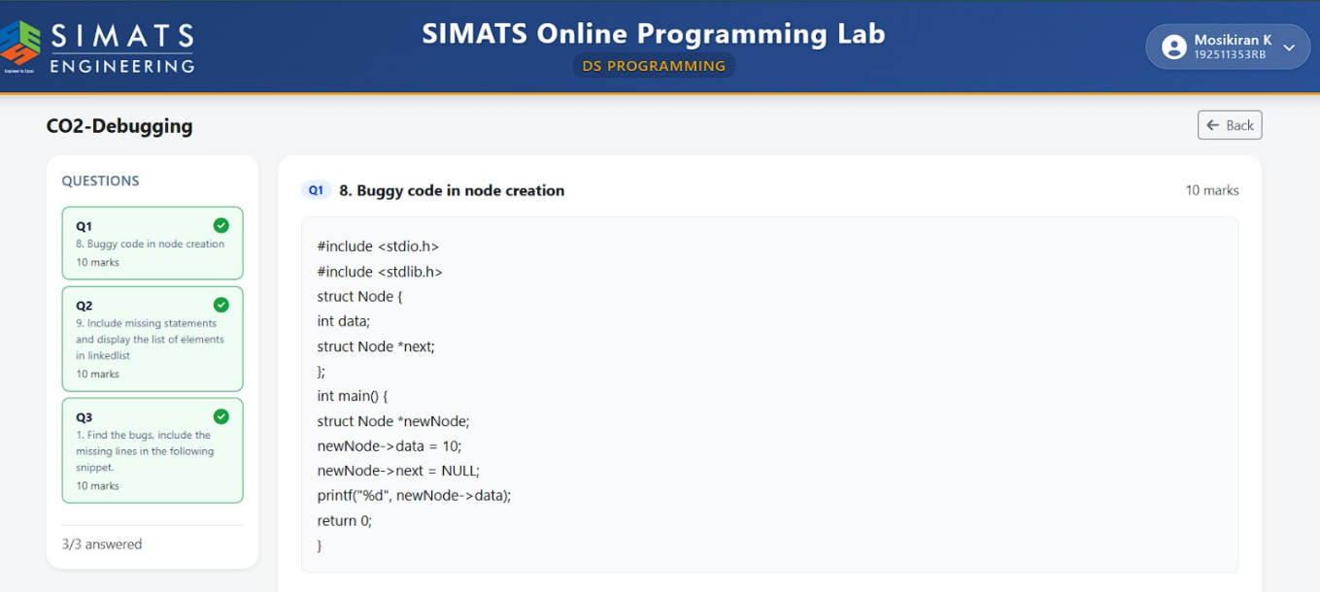

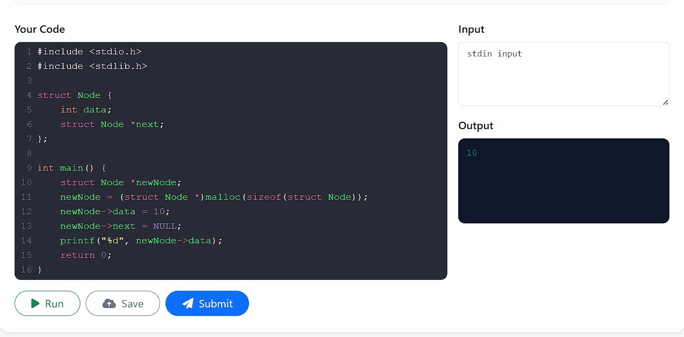

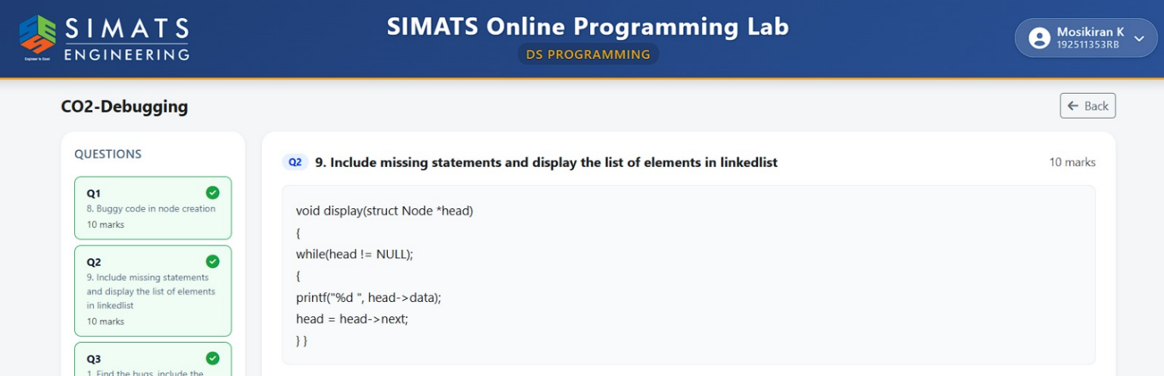

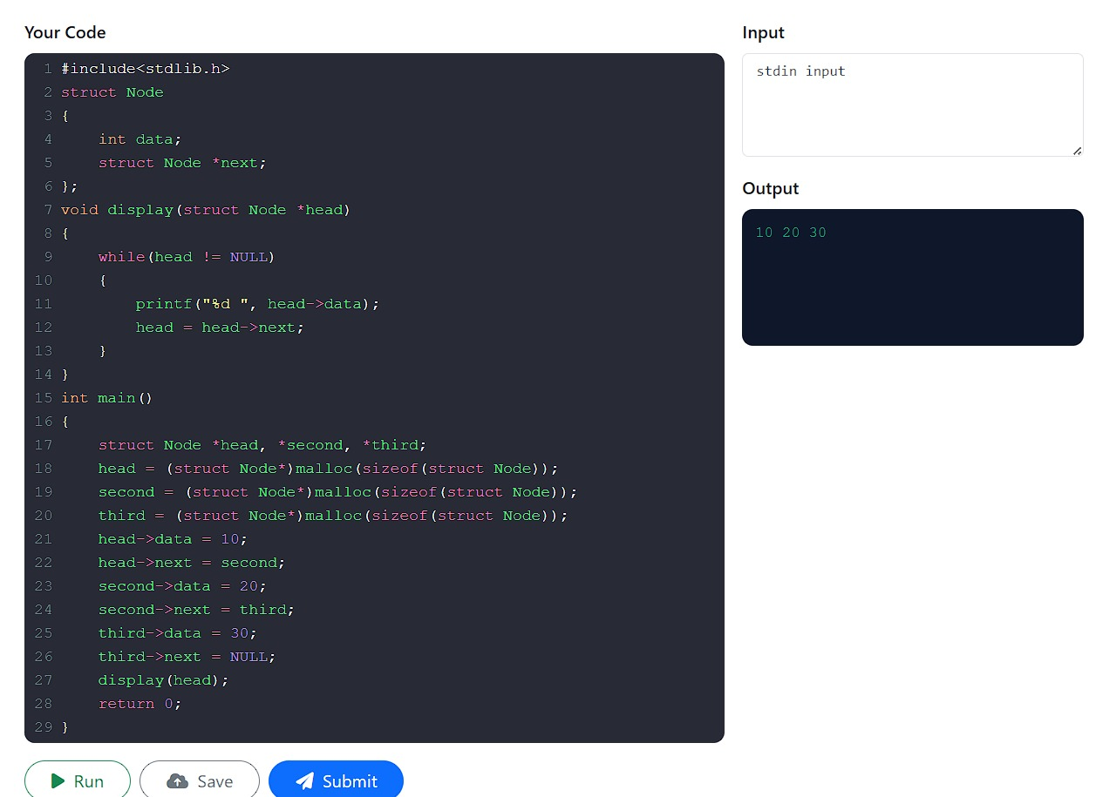

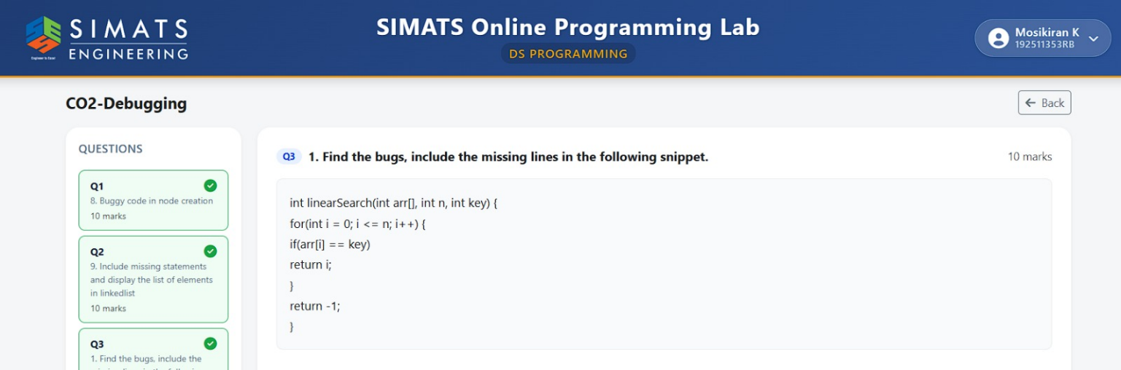

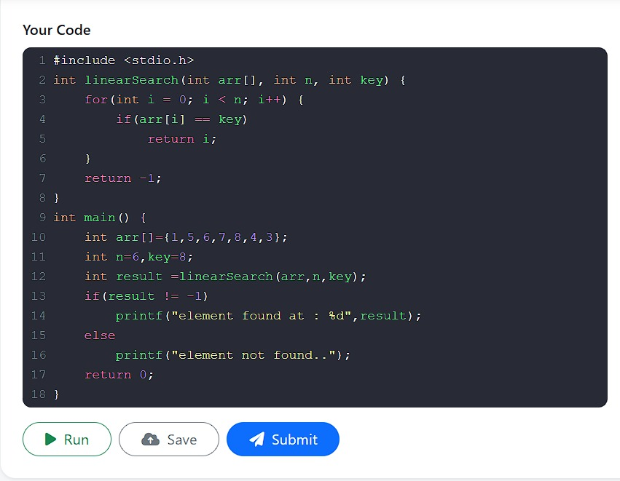S

